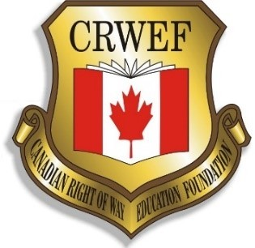2024/2025 Official Nomination Application for the

Canadian Right of Way Educational Foundation Education Scholarship

This application, with all supporting material, should be sent via e-mail to **info@crwef.ca by March 15, 2025**.

This scholarship is open to every graduating High School and Post-Secondary Student in any of our member countries.

A scholarship will be awarded each year at the International Right of Way (IRWA) Education Conference for $2,500.00 (Canadian Dollars) to a graduating high school student and Post Secondary Students who are entering/continuing a full-time course of study in any of the various fields impacting the right of way profession. The scholarship amount may be awarded to one applicant or split among more than one applicant.

1. Open the scholarship to students in university (all years) and graduating high school students.

2. Students applying who are a relative of an active IRWA Member may be given preference.

3. Scholarships are to be open to university, trades or high school students planning to

or enrolled in programs that directly relate to the IRWA.

Areas of study may include (but are not limited to) the Right of Way Field: Law, Surveying, Engineering, Planning, Real Property Appraisal, Public Administration, Environmental Studies, Real Estate and Surveying/Geomatics.

|  |  |  |  |  |  |  |
| --- | --- | --- | --- | --- | --- | --- |
| Name |  | | | | | |
| Address |  | | | | | |
| City |  | Province | |  | Postal Code |  |
| E-mail Address |  | | | | | |
| Full Time Student (select one): □ Yes □ No | | | | | | |
| Grade Point Average  (based on 9-1/4’s/ 6 Semesters of 3 years accumulative GPA) | | |  | | | |
| IRWA Member Relative: Name: | | | IRWA Member Number: | | | |

1. Minimum of 3.0 GPA, 75% or B+ to qualify.
2. GPA shall consist of the most recent three years of studies.

The Following items should be included with this application

1. Transcript for the last three (3) years of studies.
2. Letter of recommendation from faculty advisor or guidance counselor.
3. Letter of recommendation from an employer or professional associate. (if you have not had significant employment, the letter may be from a community leader with whom you are personally acquainted.)
4. Provide a brief Bio of yourself.
5. Complete the required essay

I hereby apply for the CRWEF High School Scholarship and agree that if selected as the recipient I will comply with all terms and conditions concerning its use. I further agree that if selected as the recipient I will allow the CRWEF to publish my name in its literature and press releases along with picture and Bio. I hereby certify that all information in this application is correct and true to the best of my knowledge and belief and that I have not previously been a recipient of this scholarship.

|  |  |  |  |
| --- | --- | --- | --- |
| Signature of Applicant |  | Date | / /  (Day/Month/Year) |

**Essay**

In the space provided, write an essay of a minimum of 250 words and a maximum of 500 words (provide word count) on your plans and goals in the right of way profession, how you were introduced to the profession and how you will contribute to the profession.